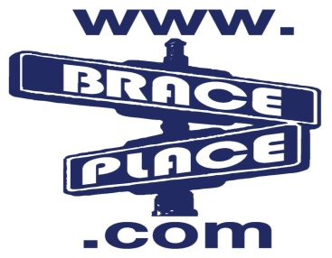
DONATION REQUEST FORM

Thank you for considering Brace Place Orthodontics as a donating sponsor to your group's event(s).
Please read the following information before submitting your request.

- Requests will be reviewed on the 15th of the month. Any submissions after that date will be included in the next month's requests.
- Donations/Sponsorships will be made to groups/teams and not to individuals.

Date: / / Donation due date: / /

Contact Name: _________________ Donation Requested:____________

Phone Number:_________________ Make checks payable to: must be a group

E-mail: _____________________________ __________________________________
Current patient/connection to Brace Place: Address to send check to:

_____________________________________ __________________________________

Purpose of Request:____________________ _________________________________

_____________________________________ Will you need our logo? YES NO
If yes, How will it be displayed?
__________________________________
Group or organization requesting donation:

_____________________________________ Have we donated to this cause/organization before? YES NO

YOU MAY SUBMIT THIS FORM SEVERAL WAYS:

Mail to: 800 Tennent Road, Manalapan, NJ 07726 Fax to: (732) 536-3396

Email to: braceplace@manalapan.com Drop off to any of our 3 locations.

FOR OFFICE USE ONLY
Donation made:______________ Check#:__________ Date: / /
- Picked-up Approved by:_____________
- Mailed

